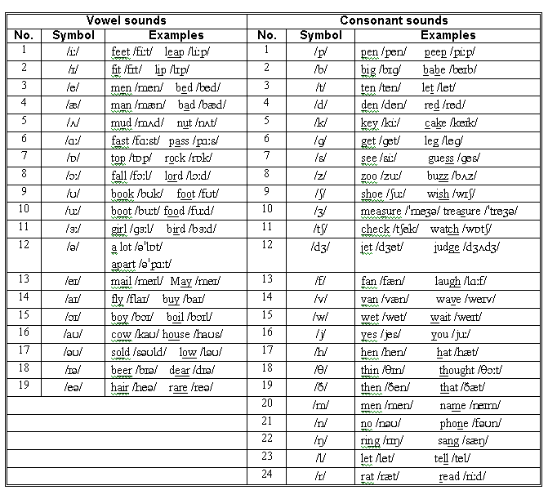
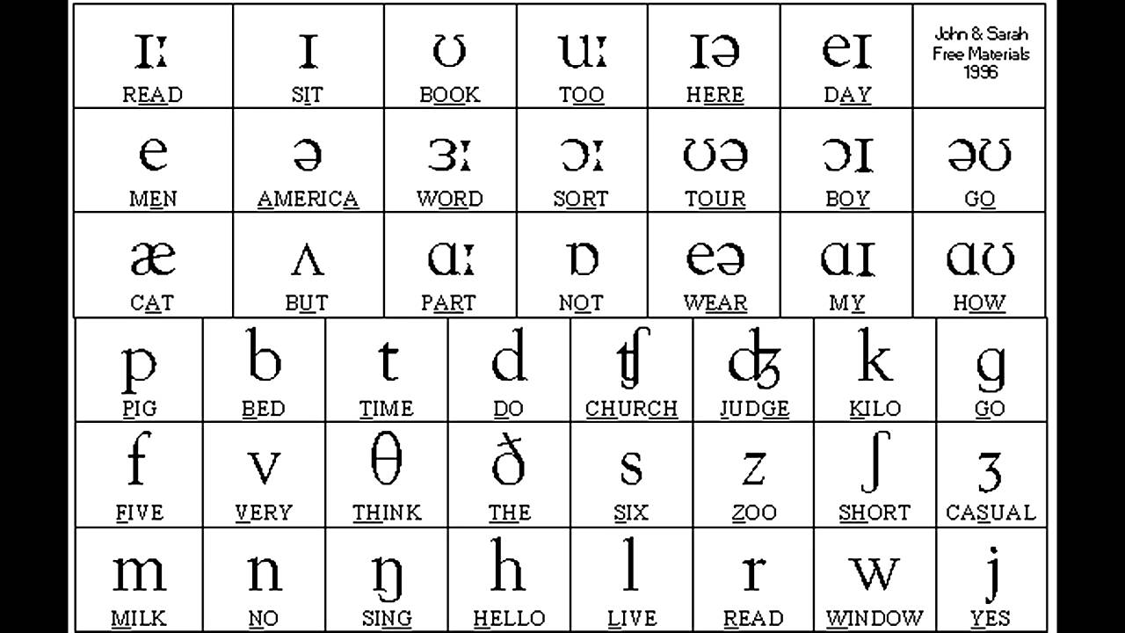

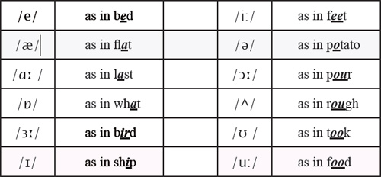
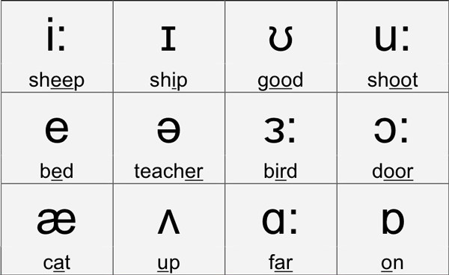
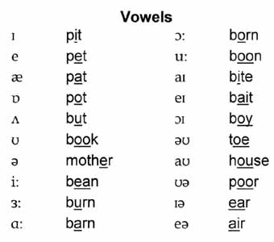

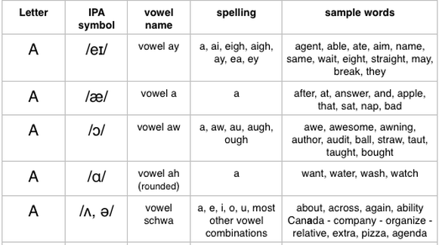
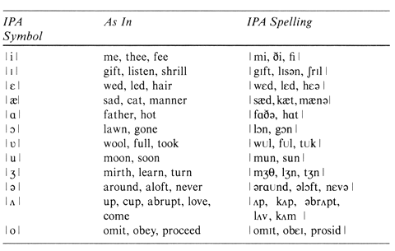
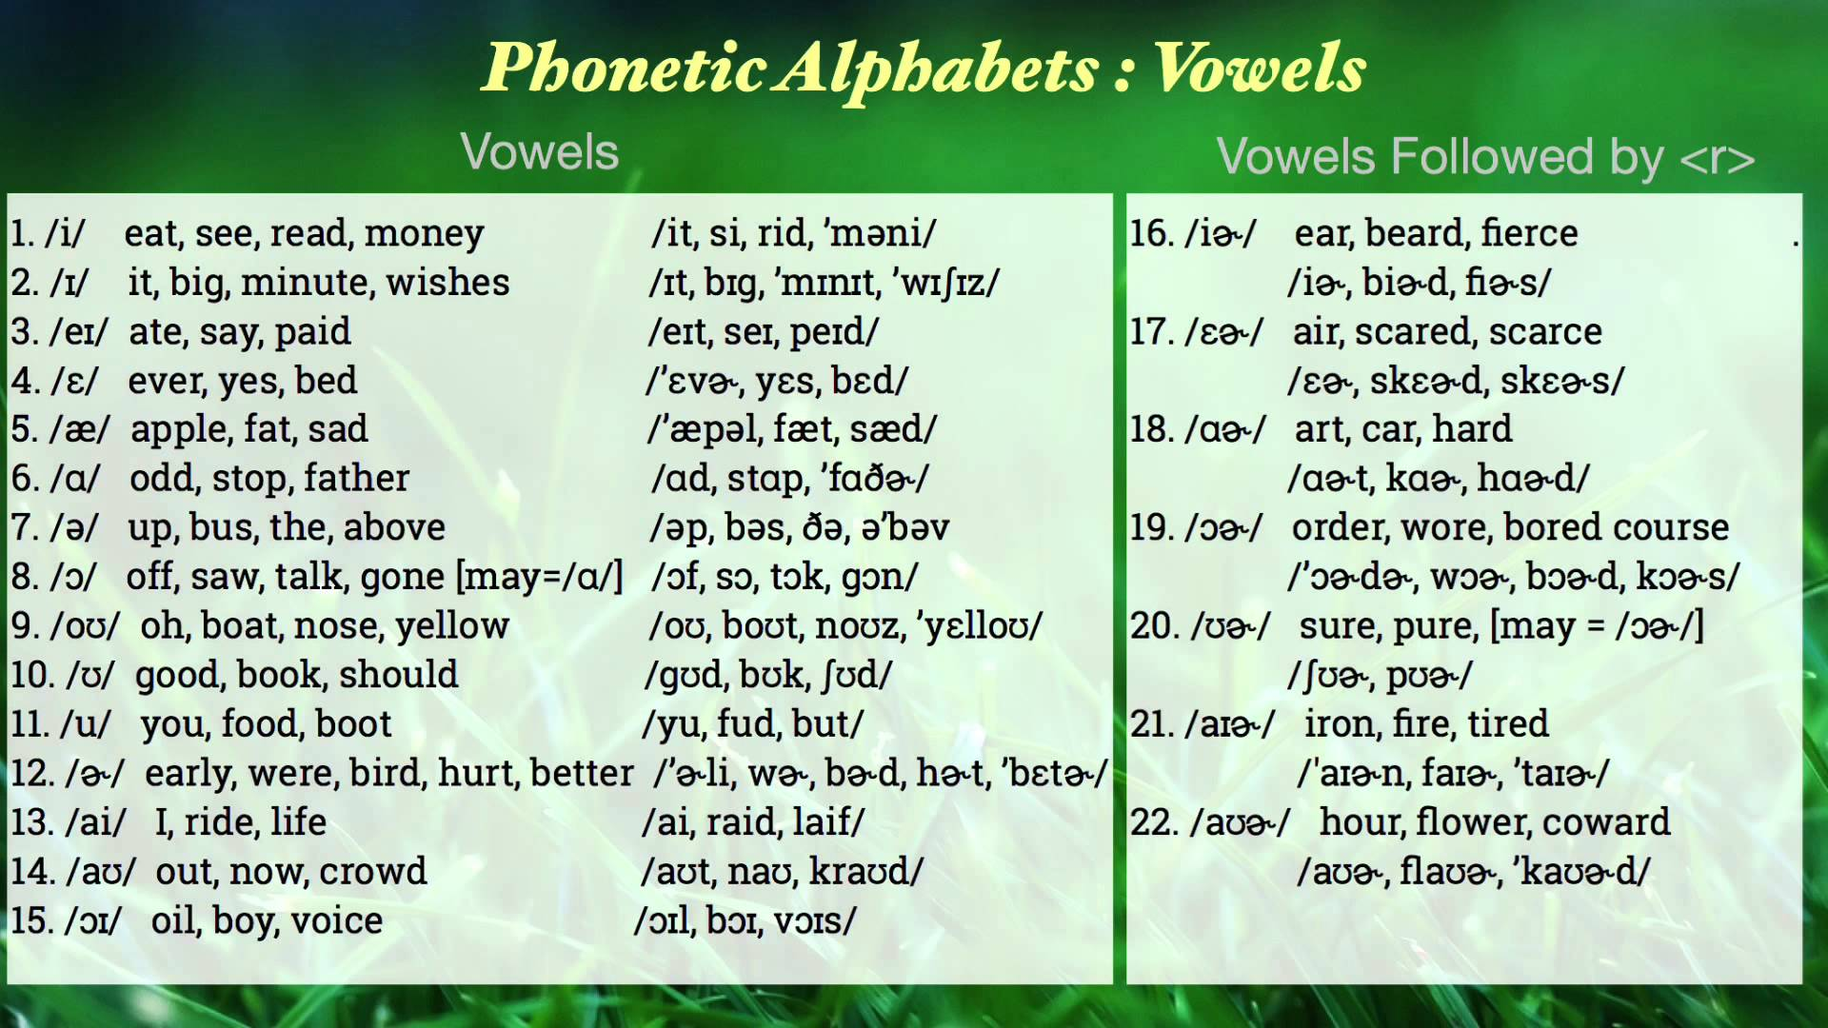

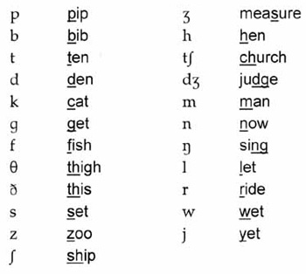
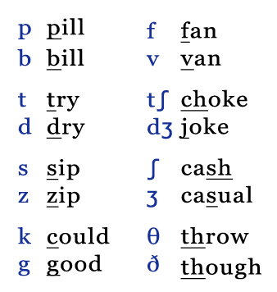
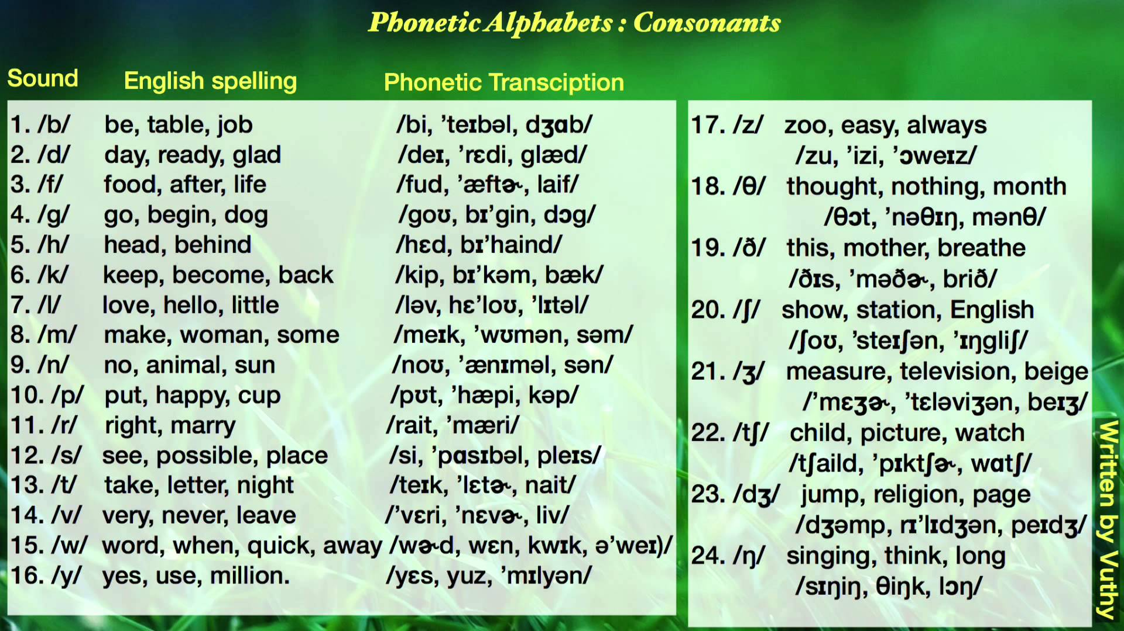
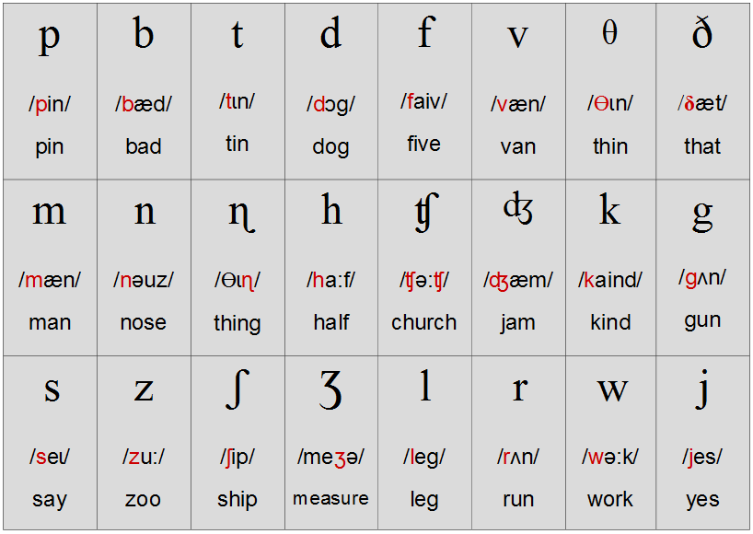

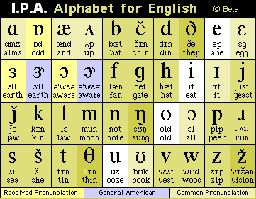
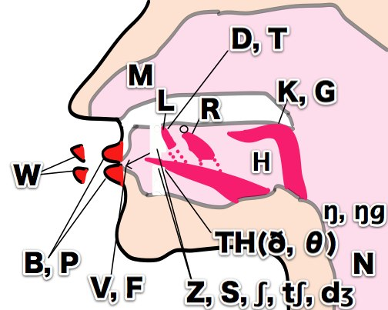
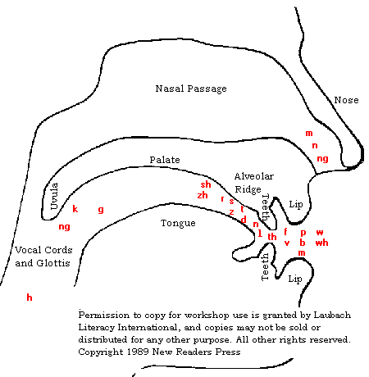
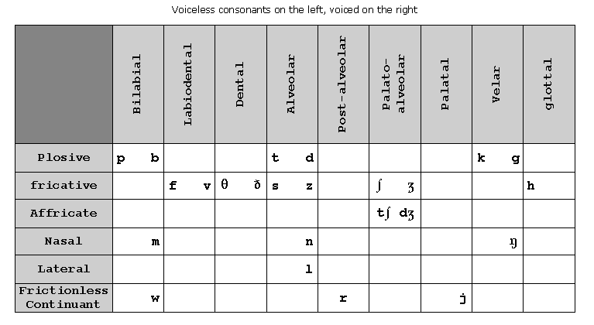
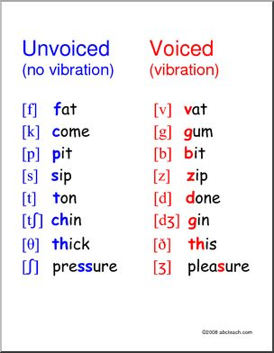
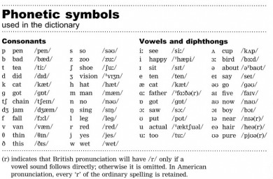
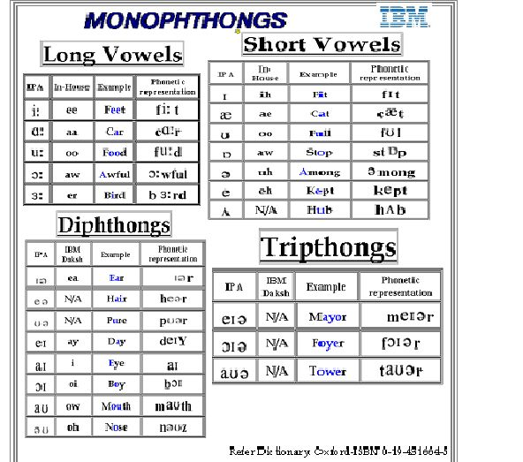

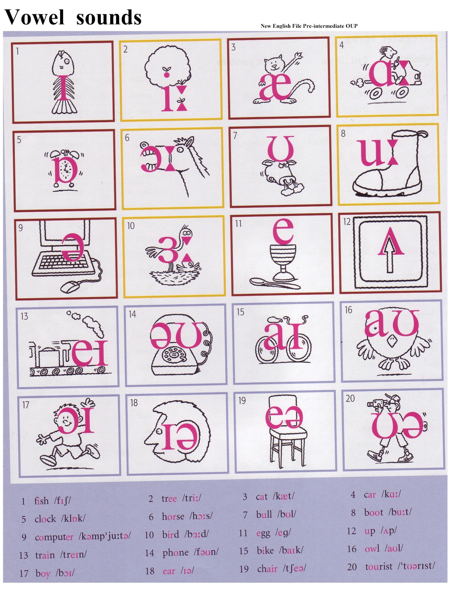
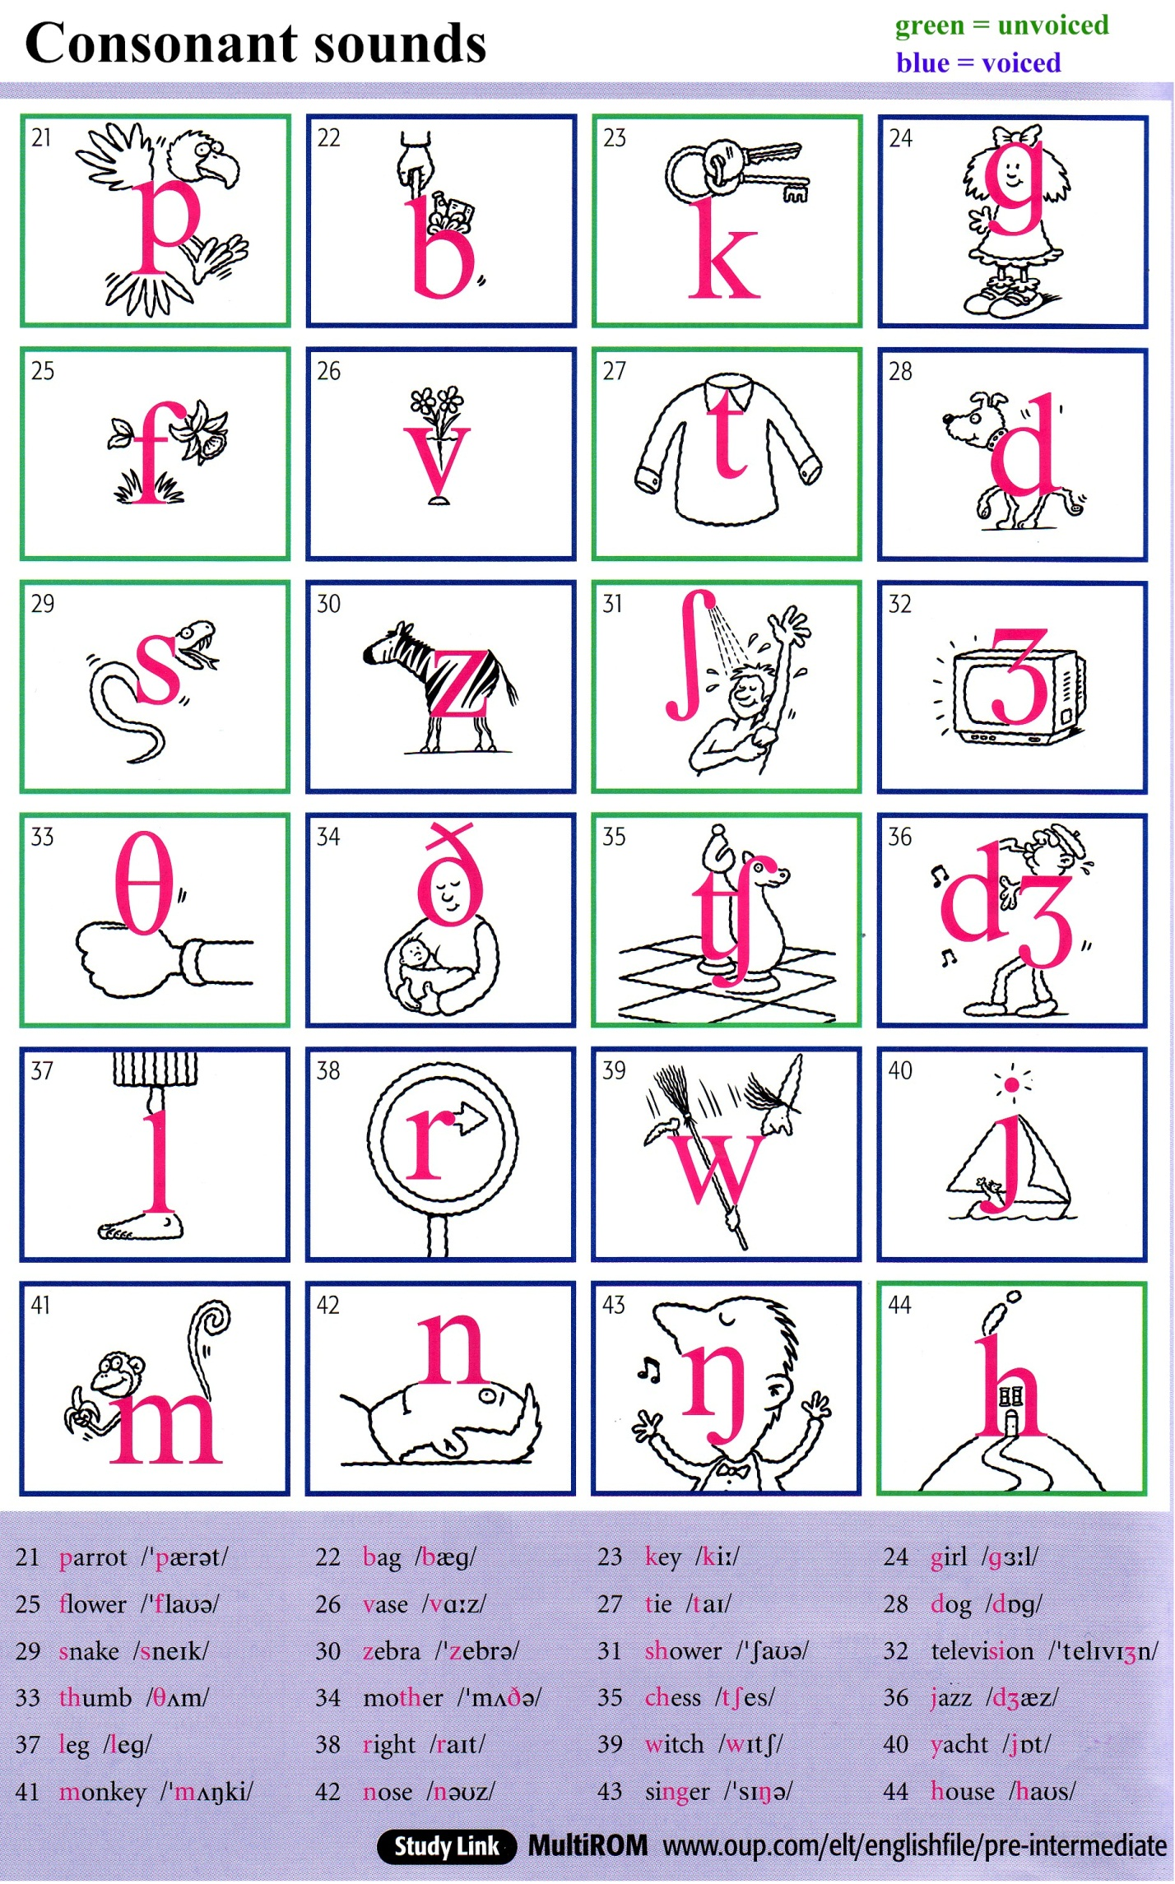
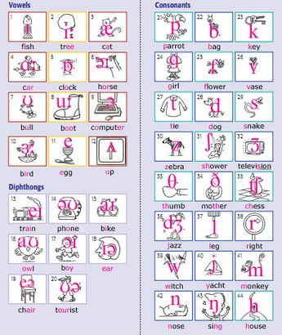
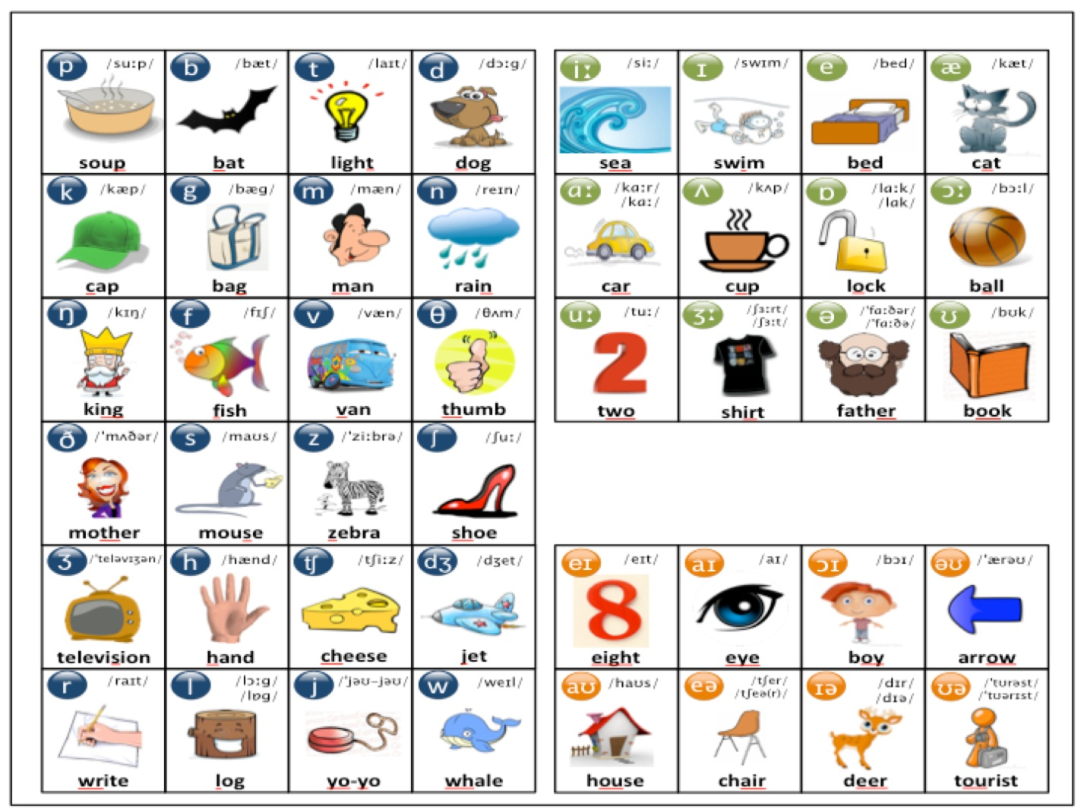
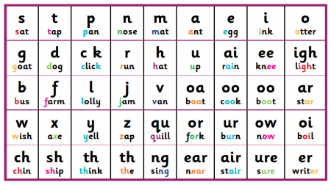

English Consonant Sounds
IPA | initial | internal | final
p | please  (pliz) | purple  (ppl) | help  (hlp)
p |  | apple  (pl) | grape  (greIp)
b | book  (bk) | noble  (nbl) | web  (wb)
b |  | cabbage  (kbI g)
f | five  (faIv) | fifty  (fIfti) | gulf  (glf)
f |  | raffle  (rfl) | off  (f)
f | phone  (fn) | hyphen  (haIfn) | nymph  (nImf)
f |  | roughly  (rfli) | tough  (tf)
v | vanilla  (vnIl) | seven  (svn) | five  (faIv)
 | thirty  (ti) | nothing  (nIŋ) | path  (p)
 | they  (eI) | father  (f) | breathe  (bri)
t | ten  (tn) | autumn  (tm) | hit  (hIt)
t |  | attain  (teIn) | mitt  (mIt)
t |  | eighty  (eIti) | freight  (freIt)
t |  |  | baked*  (beIkt)
t |  |  | white  (weIt)
t | *Pronunciation of simple past –ed ending
t | d | dish  (dI) | widow  (wId) | red  (rd)
t | d |  | adding  (dIŋ) | guide  (gd)
s | sir  (s) | thesis  (iss) | books  (bks)
s | scissors  (sIzz) | massage  (ms) | miss  (mIs)
s | center  (snt) | December  (dIsmb) | ice  (is)
s | psychology  (saIklgi) |  | six  (sIks)
s |  |  | house  (hs)
s | z | zero  (z) | freezing  (frizIŋ) | ooze  (uz)
s | z |  | fuzzy  (fzi) | jazz  (z)
s | z |  | miser  (maIz) | dishes  (dIz)
xenophobe  (znfb) | z | exit  (gzIt) | please  (pliz)
 | z | scissors  (sIzz)
 |  | she  (i) | mushroom  (mrum) | radish  (rdI)
 |  | sure  () | pressure  (pr)
 |  | schist  (Ist) | fascist  (fIst)
 |  | tuition  (tuIn) | cache  (k)
 |  | genre  (nr) | seizure  (si) | garage  (gr)
fissure
(fI)
vision
(vIn)
leisure
(li)
 |  | cheers  (s) | artichoke  (tIk | March  (m)
 |  |  | picture  (pIk) | watch  (w)
 | jump  (mp) | major  (meI)
 | gentle  (ntl) | rigid  (rIId) | cage  (keI)
 |  | badger  (b) | bridge  (brI)
 | k | king  (kIŋ) | baker  (beIk) | pink  (pIŋk)
 | k | rocket  (rkt | black  (blk)
cold  (kld) | k | October  (ktb) | attic  (tIk)
queen  (kwin) | k | equal  (ikwl)
 | k | orchid  (kId)
 | k | fix  (fIks) | cake  (keIk)
 | k | broccoli  (brkli)
g |  | good  (gd) | August  (gst) | drag  (drg)
g |  |  | foggy  (fgi)
g |  |  | exotic  (gztIk)
g |  | m | May  (meI) | humid  (hjumd) | ma’am  (mm)
 | summer  (sm) | m | autumn  (tm)
 |  | m | lamb  (lm)
n | no  (n) |  | raining  (raInIŋ) | green  (grin)
n | pneumonia  (nmnj) | sunny  (sni) | sign  (sn)
n | knife  (naIf) | unknown  (nn) | fine  (faIn)
n | ŋ |  | singer  (sIŋ) | spring  (sprIŋ)
 | ŋ | pink  (pIŋk)
w | winter  (wInt) | snowing  (snwIŋ)
w | what  (wt) | nowhere  (nw)
w | one  (wn)
w | j | yellow  (jl) | mayor  (meI)
unite  (junIt) | j | beautiful  (bjutIfl)
h | hot  (ht) | mishap  (mIshp)
l | look  (lk) | eleven  (lvn) | cool  (kl)
l | llama  (lm) | hello  (hl) | fall  (fl)
 | red  (rd) | orange  (n) | or  ()
 |  | merry  (mi) | purr  (p)

